**Experiment No. 7**

**Aim:**To implement Histogram Equalization for an image

**Objective:**

Apply CDF for histogram equalization of an image

**Input Specifications:**

Colour Image of size MXN

**Theory:**

Histogram equalization is a method to process images in order to adjust the contrast of an image by modifying the intensity distribution of the histogram. The objective of this technique is to give a linear trend to the cumulative probability function associated to the image.

The processing of histogram equalization relies on the use of the cumulative probability function (cdf). The cdf is a cumulative sum of all the probabilities lying in its domain and defined by:



The idea of this processing is to give to the resulting image a linear cumulative distribution function.

**Problem Definition:**

1. Take a color image of size MxN
2. Convert Color image to Gray Scale Image
3. Count total no. of pixels associated with each pixel intensity
4. Calculate probability of each pixel intensity in a image matrix.
5. Calculate cumulative probability
6. Normalize the cumulative probability
7. Round off each value.
8. Plot the input image, its histogram, output image and its histogram
9. Conclude by specifying the applications where histogram equalization can be used

**CODE**:

| GIm=imread('pout.tif'); numofpixels=size(GIm,1)*size(GIm,2); subplot(2,2,1) imshow(GIm); title('Original image'); subplot(2,2,2) imhist(GIm); title('Original Histogram'); %--------------------------------------------------------- HIm=uint8(zeros(size(GIm,1),size(GIm,2))); freq=zeros(256,1); probf=zeros(256,1); probc=zeros(256,1); cum=zeros(256,1); output=zeros(256,1); %freq counts the occurrence of each pixel value. %The probability of each occurrence is calculated by probf. for i=1:size(GIm,1)  for j=1:size(GIm,2)  value=GIm(i,j);  freq(value+1)=freq(value+1)+1;  probf(value+1)=freq(value+1)/numofpixels;  end end sum=0; no_bins=255; %The cumulative distribution probability is calculated. for i=1:size(probf)  sum=sum+freq(i);  cum(i)=sum;  probc(i)=cum(i)/numofpixels;  output(i)=round(probc(i)*no_bins); end for i=1:size(GIm,1)  for j=1:size(GIm,2)  HIm(i,j)=output(GIm(i,j)+1);  end end subplot(2,2,3) imshow(HIm); title('Hist Equalized image'); subplot(2,2,4) imhist(HIm); title('Equalized Histogram'); |
| --- |

**OUTPUT:**

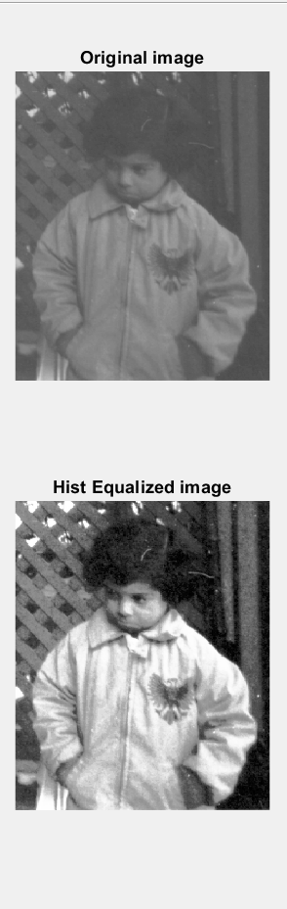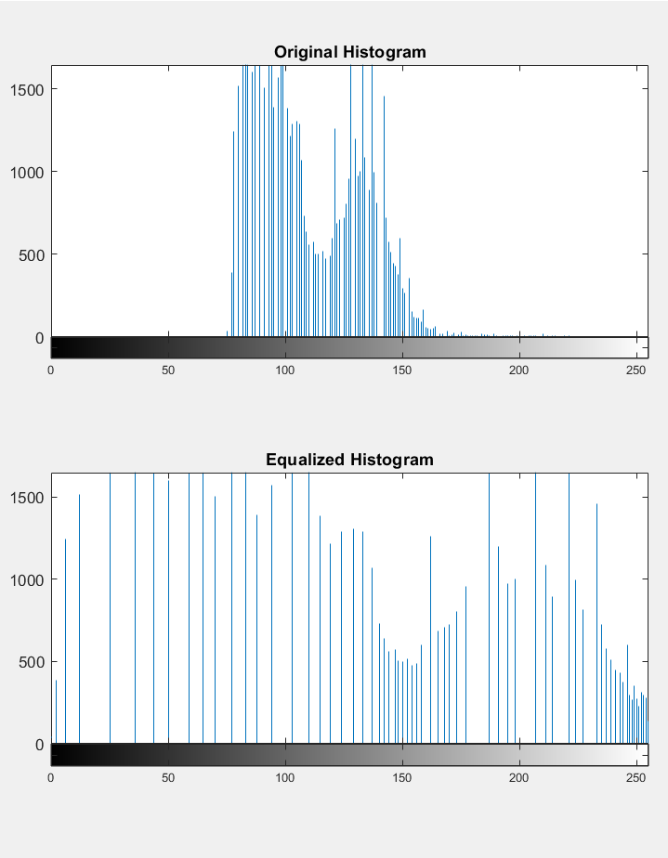

**APPLICATIONS:**

* To achieve better quality images in B&W color scales in medical applications like X-rays, MRI’s and CT scans.
* To better detail in photographs that are either over or under-exposed.

**CONCLUSION**:

Histogram Equalization is a computer image processing technique used to improve contrast in images. It accomplishes this by effectively spreading out the most frequent intensity values, i.e. stretching out the intensity range of the image. In this practical, we did histogram equalization on an image and observed the changes in the histogram using MATLAB.

**NAME:** Junaid Altaf Girkar

**SAP ID:** 60004190057

**BATCH:** BE Comps A2